National Bison Range Complex Weed Control Contract 2014
Statement of Work

Background
Integrated invasive species management practices are implemented on the National Bison Range Complex (NBRC) as a general conservation measure for US Fish and Wildlife Service (Service) lands. Locations within the NBRC have been targeted for a contractual agreement to control multiple invasive plant species (weeds).
These practices are intended to limit spread of weeds and weed seeds off Service lands, decrease occurrence and density of weeds on Service Lands, and to improve the overall quality of the habitat while maintaining biodiversity.

Scope
The contractor shall survey and treat all areas detailed below and identified on the attached maps. Actual size of these project areas is subject to change due to physical and environmental factors, including but not limited to fluctuating water levels, sensitive wildlife or vegetation issues, and general access. The contractor shall furnish all necessary labor, equipment, GPS technology and materials required to successfully complete these tasks.

Work Requirements
This contract is being offered for treatment of target invasive plant species during the phenological stage in which chemical control is the most effective. The Contractor is required to schedule vegetation management activities to maximize the effectiveness of control efforts and minimize introduction and spread of invasive plants. Target specificity and limited non-target effects are paramount.
Contractor vehicles are required to be washed and free of weed seeds prior to implementing any contractual work on Service lands. Contractors will take all necessary actions to minimize disturbance to the sites.
Contractor is required to have current Montana state applicators license for all applicable settings (aquatic and rangeland specifically), NPDES permits, and necessary licensure for operation of equipment.

Project specific details by location:
NBR (National Bison Range) - Attachment A (map)
Shape | Project Area | Target | Acreage | Timing | Plant Stage | Equipment | Method | Comments
Polygon | NBR- hardin/mission crk no. of tour rd/triangle pc | whitetop | 125 | Mid May-Mid June | emergence-early bloom | truck/utv | spot/boom | Small patches throughout grasslands in this area
Polygon | NBR- ravalli ponds | Spotted knapweed, toadflax, teasel, sulfur cinquefoil | 100 | June | emergence-early bloom | atv/utv | spot/boom | Throughout unit
Polygon | NBR- Hardin Tract | Spotted knapweed, toadflax, teasel, sulfur cinquefoil | 100 | June | emergence-early bloom | atv/utv | spot/boom | Throughout unit

WMD (Wetland Management District) - Attachment B (map)
Shape | Project Area | Target | Acres | Timing | Plant Stage | Equipment | Method | Comments
Polygon | WMD- Sandsmark | whitetop, teasel | 80 | Mid May-Mid June | emergence-early bloom | truck/utv | spot/boom | W 80 and hanging 80
Polygon | WMD- Johnson 80 south half | whitetop, teasel | 20 | Mid May-Mid June | emergence-early bloom | truck/utv | spot/boom | South half of unit
Polygon | WMD- Herak | whitetop, teasel | 40 | Mid May-Mid June | emergence-early bloom | truck/utv | spot/boom | Throughout unit
Polygon | WMD- Montgomery | whitetop, teasel | 40 | Mid May-Mid June | emergence-early bloom | truck/utv | spot/boom | Throughout unit
Acreages given are a government estimate only.

Deliverables or Delivery Schedule
Treatment cycles will be measured monthly and deliverables should be provided to the Refuge Deputy Project Leader within 30 days following the end of a treatment cycle. Deliverables for each treatment cycle should include the following:
- Pesticide application records
- Summary report of treatments with a list of species present, density and vigor of infestation, treatment coverage, issues/constraints, and comments or recommendations.
- A GPS tracklog of all work on Service lands, points with associated acreage estimate and chemical output.

Government-Furnished Equipment and Government-Furnished Information
No Government furnished equipment available; all equipment to be furnished by Contractor.
The Government will furnish information regarding location of staging areas, access, project limitations (i.e. off road vehicle or chemical restrictions), sensitive plant or animal locations, and maps. The Government will also furnish keys when applicable.

Place of Performance
National Bison Range Complex (see attached maps)

Period of Performance
Full contract period through December 31, 2014- with the period of performance in general being May-September and time for reporting given. See tables for specific timing requirements, treatment of target species outside of the window of efficacy will not be considered toward project completion.
Bid Requirements
Bids must include a table that specifies costs for application and for pesticides for each of the management units, per the example below. The government may award the contract for some or all of the management units. At its discretion, the government may supply some herbicide in order to allow for increased treatment acreage.

Management Unit | Included Project Areas | Application Costs | Herbicide Costs | Total Costs
National Bison Range | 3
WMD | 4
Total | 7 | Total Application$ | Total Herbicide $ | Grand Total$

Pre-Bid Site Visit
For pre-bid site visit inquiries contact Amy Lisk at the National Bison Range (406) 644-2211 ext 217.

Attachment A:
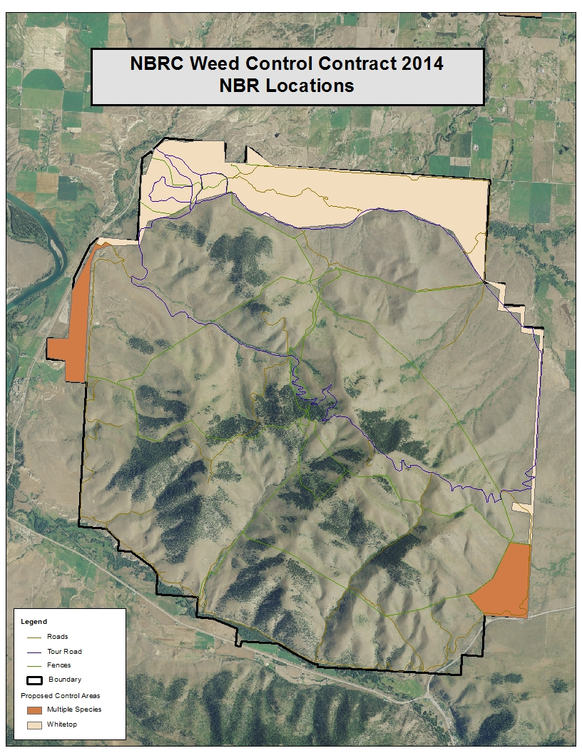
Attachment B:
