Law Enforcement / Federal Air Marshal Service
(LE/FAMS)

STATEMENT OF WORK (SOW)

Ballistic Resistant Panels for
LE/FAMS UK Non-Descript Bag (NDB)

PURPOSE:

The purpose of this SOW is to obtain mission essential support equipment necessary for meeting LE/FAMS mission requirements.

SCOPE:

The LE/FAMS intends to purchase a total of eight hundred (800) units of Ballistic Resistant Panels measuring 5” W x 8” L for mission deployment weapon storage purposes.

BACKGROUND:

LE/FAMS secures domestic and international commercial transportation assets using specially trained, covertly deployed, highly mobile, and geographically dispersed workforce of federal law enforcement agents. To support the LE/FAMS mission, durable mission essential support equipment is critical to meeting unique weapon storage requirements and is vital to carrying out its law enforcement responsibilities. The LE/FAMS Flight Operations, Law Enforcement Liaison Section program office supports multiple users whose duties vary across the service requiring a broad spectrum of equipment and services.

TECHNICAL REQUIREMENTS/TASKS/OUTCOMES:

The Ballistic Panels shall be produced to the same model number and build specifications as a compliant Threat Level IIIA body armor ballistic panel currently listed on the National Institute of Justice (NIJ) Compliance Product List (CPL), as certified under the NIJ-0101.06 Standard. The panels shall exhibit the same construction, materials, layer counts, covering, attention to detail and quality.

- Ballistic Panels shall be rectangular in shape and measure 5” W X 8” L in size.
- Ballistic Panels shall weigh less than 1.2 Pounds per Square Foot (lbs/ft2).
- Ballistic Panels shall include a black color, durable, water resistant material cover, such as black Cordura fabric, stitched closed over the ballistic material.
- Ballistic Panels shall be labeled and clearly identify the:
- Associated IIIA Vest Model Number
- Size
- Location of Manufacture
- Date of Manufacture
- Serial Number
- Warranty Period
- Care Instructions
- Attachment of the label must not affect the waterproof integrity of the ballistic panel cover.
- Ballistic Panels are not subject to NIJ certification.
- Ballistic Panels shall be warranted for a minimum of seven (7) years to be free from all defects in materials and workmanship.
- Ballistic Panels shall not be rigid polyethylene.
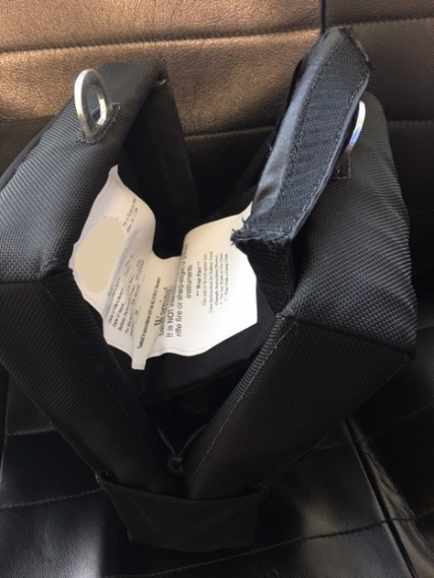
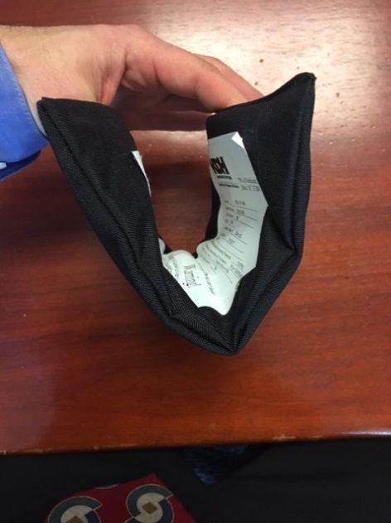
- Ballistic Panels shall be one full piece that is flexible enough to fold in half along the 5” axis, placed inside a storage case, and be closed with minimal force. A technically acceptable product will be able to fold, and be placed into the intended storage case, as illustrated in the pictures below.

- Ballistic Panels shall contain hook and loop fasteners sewn onto the non-labeled side.
- The “loop” side of the hook and loop fastener shall be sewn onto the panel cover.
- Preference is for a near-total coverage of hook and loop; minimum coverage shall not be less than 4” W x 6” L.
- The corresponding “hook” side is not required.
- The picture below is illustrative of the requirement.
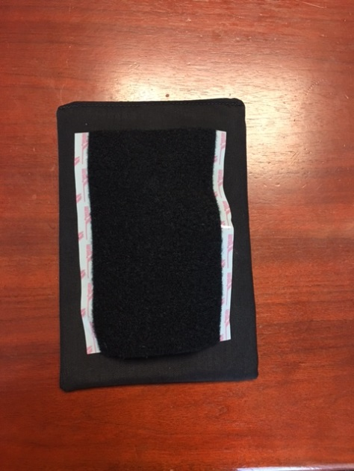

DELIVERY / SHIPPING:

The order shall be completed in full within 90 days of being placed and delivered to:

ACY Logistics Center
ATTN: Sandi Weimer
200 West Parkway Drive
Suite 300
Egg Harbor Township, New Jersey 08234

